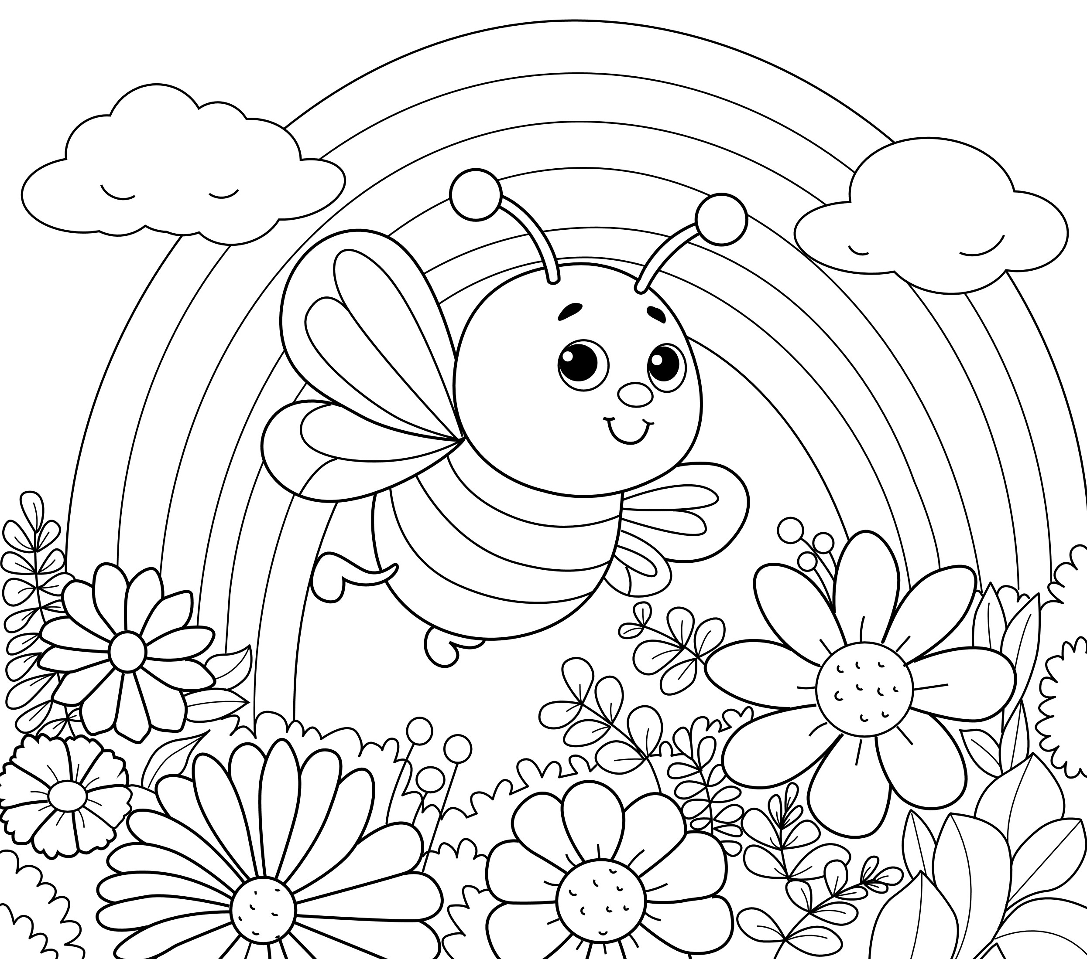

Name_____________________________
Class 3046 preschool/daycare/pre kindy

School_____________________________

