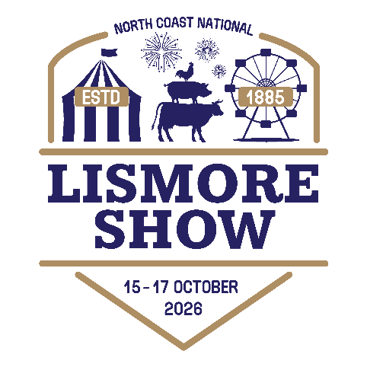
REGISTER NOW!

Bring your students to the Lismore Show for a day of education and fun!
Thursday 15 October or Friday 16 October 2026. Preference will be given to schools who are exhibiting items in the Show
Please complete this registration form and email to: schools@northcoastnational.com.au
by Monday, 5 October 2026

ATTENDANT DETAILS
School ________________________________________________________

Contact Name___________________________________________________

Address ________________________________________________________

Email of responsible teacher_________________________________________

Phone___________________________ Mobile__________________________

Attendance Day (please circle) Thursday Friday

Number of students and teachers ____________________________________

Signature________________________________ Date_____________________

